Processing Assistant

V0.0.1.6

December 12, 2016

Table of Contents

1 Overview 3

1.1 Supported versions 3

1.2 Category 3

1.3 Special considerations 3

2 Deployment 3

2.1.1 Install Relativity application to library 3

2.1.2 Install Relativity application to workspace 4

3 Input and preparation 4

3.1 To create a processing set 4

4 Results of running 6

5 Disclaimer 7

Overview

This application allows a user to create a processing set by pointing at a directory which contains folders of custodian data. The resulting processing set will contain one processing data source for each folder in the selected directory and will associate the data source to the custodian based on the folder name.

Supported versions

This solution is has been run in Relativity versions 9.3, 9.4.

Category

* This custom solution consists of the following components:
* Relativity Application
* Custom Page

Special considerations

* This application is a proof of concept and should not be used in a production environment.
* This application should only be installed in workspaces which have Relativity processing installed.
* Person-Type Custodian data folders must be named in the following formats for the custodian to be created properly: <*First Name*>_<*Last Name*> or <*Last Name*>, <*First Name*>. Using a different naming convention may cause unexpected results.
* Custom components may not exhibit the same performance and behavior as native Relativity features.
* While each solution is carefully built and thoroughly tested to work on your version of Relativity, they are not considered core features and are not eligible for the same level of support as the Relativity platform.

Deployment

### Install Relativity application to library

1. Log in to Relativity.
2. Navigate to the **Admin/Home** section.
3. Click on the **Application Library** tab.
4. Click on the **Upload Application** button.
5. Click on the **Browse…** button next to **Application File**.
6. Select the file **RA_Processing_Assistant.rap** and click **Open**.
7. Click **Save**.

### Install Relativity application to workspace

1. Log in to Relativity.
2. Navigate to the **Home** section.
3. Click on the **Application Library** tab.
4. Click on the application **Processing Assistant.**
5. Under **Workspaces Installed**, click on the **Install** button.
6. Next to **Workspaces**, click on the **ellipsis […]** button.
7. Select one or many workspaces to install the application to.
8. Click **OK**.
9. Click **Save**.

Input and preparation

To create a processing set

1. Click on the **Processing Assistant** tab.
2. Enter the following information:
   1. **Name** – enter the name of the processing set.
   2. **Processing profile** – select a processing profile.
   3. **Source path** – select a source path which contains the custodian folders.
   4. **Destination**: The Custodian type to be created: *Custodian* or *Project*. Choosing *Custodian* will create a Person-Type Custodian while choosing *Project* will create an Entity-type Custodian.
   5. **Custodian level** – enter the folder level at which the custodian folders exist in the selected source path.

This is the number of folders down from the selected source path to look for the custodian folders. For example, if the selected source path was the *Processing Data Import* folder shown below, the custodian level would be 1 because the custodian folders are just 1 level down from the *Processing Data Import* folder.

Sample custodian folders

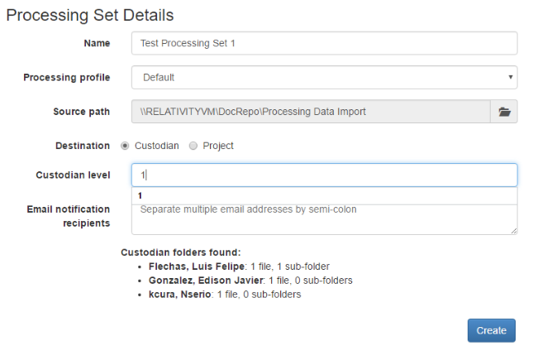

Notice that each time the *Custodian level* field is changed, a preview of the Custodian folder founds is shown at the bottom of the page.

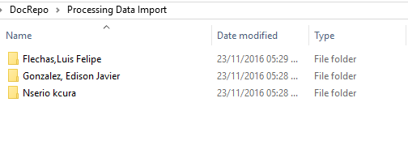

* 1. **Email notification recipients** – Optionally enter a list of email addresses separated by a semi-colon of those whom you want to receive notifications while the processing set is in progress.

Inputs

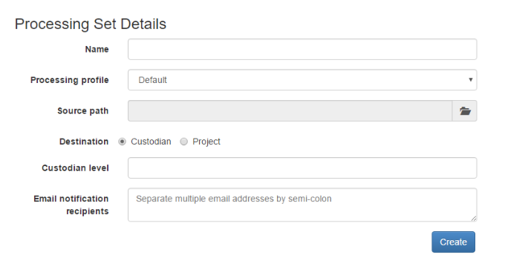

1. Click **Create**.

Results of running

The processing set will be created and a processing data source will be added to the processing set for each folder contained in the processing source location at the selected custodian level.

Sample processing set

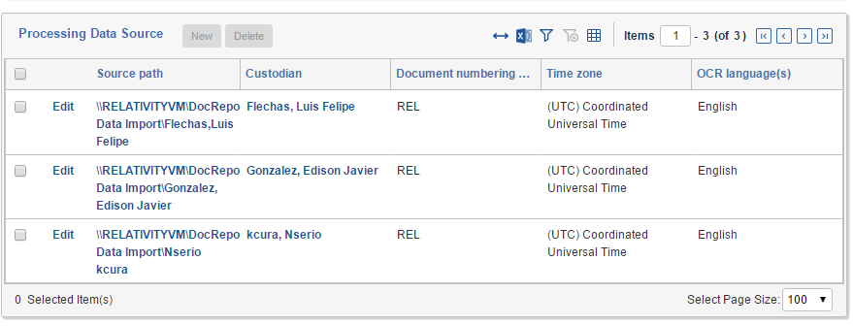

From the example shown above, 3 folders are found 1 level down from the *Processing Data Import* folder. One processing data source is added for each of those custodian folders.

Each processing data source will be created and associated to a custodian with the following settings:

* **Source path** – the path to the custodian folder.
* **Custodian** – the custodian which is extracted from the custodian folder name.
* **Document numbering prefix** – the document numbering prefix set in the selected processing profile.
* **Time zone** – the time zone set in the selected processing profile.
* **OCR Language(s)** – the OCR languages set in the selected processing profile. If the custodian does not already exist, one will be created with the following settings:
* **Custodian Type** – Person or Entity depending on the selected choice on the *Destination* field.
* **First Name** – the first name extracted from the custodian folder name.

The custodian folder should be named in the format of <*First Name*>_<*Last Name*> or <La*st Name*>, <Fir*st Name*>. This field will not be filled for Entity-Type Custodians.

* **Last Name** - the first name extracted from the custodian folder name.

The custodian folder should be named in the format of <*First Name*>_<*Last Name*> or <La*st Name*>, <Fir*st Name*>. This field will not be filled for Entity-Type Custodians.

* **Full Name** – For Person-Type custodians the *Full Name* will be <*Last Name*>, <*First Name*>. For Entity-Type Custodians, the name of the folder will be the *Full Name* of the Custodians.

Once the processing set has been created, it can be processed using the processing set console.

Disclaimer

This script is intended for use only in the Relativity versions specified in this document and run under the guidelines presented. While each solution is carefully built and thoroughly tested to work on the versions of Relativity specified in this document, this script is not a core feature of Relativity and is not eligible for the same level of support as the Relativity platform.

In addition, custom components may not exhibit the same performance and behavior as native Relativity features. Custom solutions do not specify permission settings unless explicitly requested by the client.